Rural Safety: An Examination of Horseback Riding Injuries

INTRODUCTION:

You are an insurance actuary who evaluates the likelihood of accidents and quantifies the contingent outcomes in order to minimize loss, both direct and indirect. Not only do you have to account for economic variables, you also have to account for sometimes inconsistent, unpredictable human behavior.

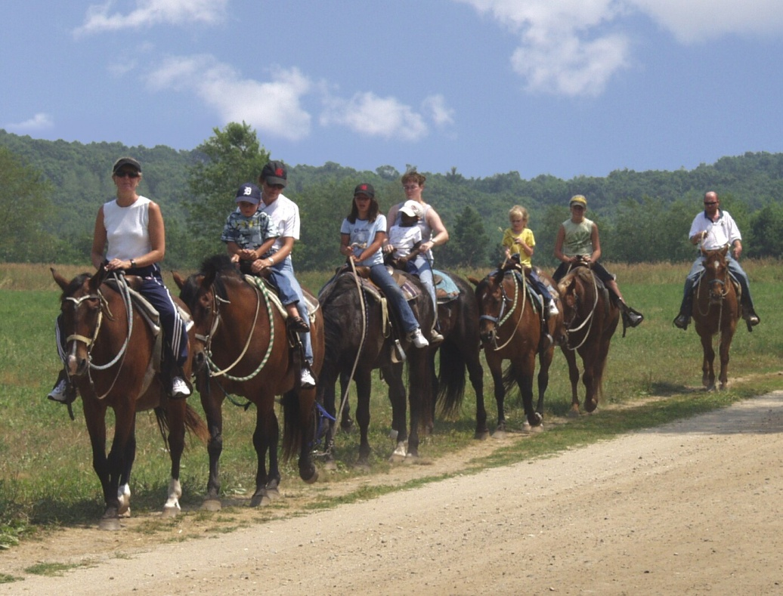

TASK:

Today, an insurance company approached you and your co-investigator(s) with a concern for horseback riding injuries. The company asked that your team research this topic in an effort to understand more fully the scale of horseback riding-related risks and those most at risk. Upon completing your research, you should be able to answer the following questions:

- What is the nature of horseback riding injuries?
- Who is most at risk for these types of injuries?

PROCESS:
Part I:

Working in investigation teams, you will review the following websites to gain a deeper understanding of horseback riding injuries. As you work through Resources A to I, document your investigation using the formatted “rural safety investigators’ notebook”—attached to this document. If you finish early, feel free to add to your research by finding additional resources on the Web—just make sure to document your source!

Resource A: “Current Trends Injuries Associated with Horseback Riding”
http://www.cdc.gov/mmwr/preview/mmwrhtml/00001626.htm

Resource B: “Horseback riding injuries among children and young adults”
http://findarticles.com/p/articles/mi_m0689/is_n2_v39/ai_15828754/

Resource C: “Horses and Children”
http://www.cdc.gov/nasd/docs/d000901-d001000/d000978/2.pdf

Resource D: “BIAK Fact Sheet”
http://www.biak.us/education/fact-sheets/bi_horse

Resource E: “Horseback riding is risky business”
http://www.youtube.com/watch?v=QCD-aevXfeQ

Resource F: “Why Should 4-H Horse and Pony Youth Wear Certified Equestrian Helmets?”
http://www.joe.org/joe/2004december/tt4.php

Resource G: “Legislators pass horseback riding helmet bill”
http://www.sun-sentinel.com/news/local/breakingnews/sfl042809--horse-helmet,0,1288033.story

Resource H: “Riding Helmets: They're Hot, But They're Not Hot Enough”
http://inventorspot.com/articles/helmets_25834

Part II:

Using the resources from Part I and any other initial research you have conducted, your team needs to create a brief “investigative report” (1-2 pages) directly addressing the following questions:
- Why are these types of horseback riding injuries a problem?
- Who is most at risk for horseback riding injuries?
- What further question(s) do you have about horseback riding injuries that is left unanswered by your research?
Please type your final report and cite sources using APA style.

CONCLUSION

Congratulations, you completed “Phase One.”

Now, on to “Phase Two”. Dr. Mazur is on her way to a national conference, the National Institutes of Farm Safety (NIFS), where she is giving a presentation on the rise in tractor-related accidents in Kentucky. Utilizing your “investigator’s notebook” and your “investigative report,” you will need to create a podcast for the Professors to use as part of their presentation. The substance of your podcast will need to address the two questions that framed your research: 1) What is the nature of horseback riding injuries and 2) Who is most at risk for horseback riding injuries. A third question that needs to be included is “Why are Kentucky insurance agents worried about horseback riding injuries?” Good news! You work for a large firm and will be assigned to collaborate with a panel of three to four other investigators to complete your podcast. Please feel free to embellish your podcasts with sound effects and creative dialogue.

EVALUATION

Area of Evaluation |  | Possible Points | Student Score
Content | Investigators’ Notebook | 20
 | Investigative Report | 20
 | Podcast * | 30
Process | Use of Class time, working with fellow investigators, use of feedback, etc. | 15
Product | Use of medium, including spelling, grammar, use of sound, etc. | 15
Total Score |  |  | /100

* Criteria for final podcast will be given separately

