Rural Safety: An Examination of ATV injuries

INTRODUCTION:

You are an insurance actuary who evaluates the likelihood of accidents and quantifies the contingent outcomes in order to minimize loss, both direct and indirect. Not only do you have to account for economic variables, you also have to account for sometimes inconsistent, unpredictable human behavior.

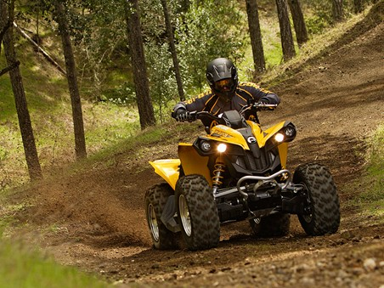

TASK:

Today, an insurance company approached you and your co-investigator(s) with a concern for the rise in All Terrain Vehicle (ATV) injuries. The company asked that your team research this topic in an effort to understand more fully the scale of ATV-related risks and those most at risk. Upon completing your research, you should be able to answer the following questions:

- What is the nature of ATV injuries?
- Who is most at risk for these types of injuries?

PROCESS:
Part I:

Working in investigation teams, you will review the following websites to gain a deeper understanding of ATV injuries. As you work through Resources A to I, document your investigation using the formatted “rural safety investigators’ notebook”—attached to this document. If you finish early, feel free to add to your research by finding additional resources on the Web—just make sure to document your source!

Resource A: “ATV injuries” Podcast by Dr. Greg David
http://www.publicbroadcasting.net/wuky/news.newsmain?action=article&ARTICLE_ID=1302895

Resource B: “Study shows inadequate guidelines for ATV Riders”
http://www.publicbroadcasting.net/wuky/news.newsmain?action=article&ARTICLE_ID=1368209

Resource C: “ATV-Related Deaths and Injuries for All Ages: 1985-2007”
http://www.atvsafety.gov/stats.html

Resource D: “Kentucky data on ATV injuries”
http://www.atvsafety.gov/state/kentucky.html

Resource E: “If you ride, Do it right”
http://www.youtube.com/watch?v=-diP3hetzaM

Resource F: “ATV Injuries and Deaths Continue to Rise”
http://www.consumeraffairs.com/news04/2008/10/cpsc_atvs02.html

Resource G: “ATV Study at University of Kentucky Seeks to Reduce Accidents”
http://www.newsinferno.com/archives/3327

Resource H: “Characteristics of All-Terrain Vehicles and Their Operators on Kentucky Farms”
http://www.mc.uky.edu/scahip/characteristicsofallterrainvehiclesandtheiroperatorsonkyfarm.html

Resource I: “Children and ATVs: Riding in Harm’s Way”
http://www.kyyouth.org/Publications/05brief_ATV.pdf.pdf

Part II:

Using the resources from Part I and any other initial research you have conducted, your team needs to create a brief “investigative report” (1-2 pages) directly addressing the following questions:
- Why are these types of ATV injuries a problem?
- Who is most at risk for ATV injuries?
- What further question(s) do you have about ATV injuries that is left unanswered by your research?
Please type your final report and cite sources using APA style.

CONCLUSION

Congratulations, you completed “Phase One.” As you most likely know all too well, the CEO of the insurance company, Dr. Mazinator is demanding and unrelenting. She is now on her way to a national conference, the National Institutes of Farm Safety (NIFS), where she is giving a presentation on the rise in tractor-related accidents in Kentucky. Utilizing your “investigator’s notebook” and your “investigative report,” you will need to create a podcast for Dr. Mazinator to use as part of her presentation. The substance of your podcast will need to address the two questions that framed your research: 1) What is the nature of ATV injuries and 2) Who is most at risk for ATV injuries. A third question that needs to be included is “Why are Kentucky insurance agents worried about ATV injuries?” Good news! You work for a large firm and will be assigned to collaborate with a panel of three to four other investigators to complete your podcast. Please feel free to embellish your podcasts with sound effects and creative dialogue. In other words, make the Swanimator look good.

EVALUATION

Area of Evaluation |  | Possible Points | Student Score
Content | Investigators’ Notebook | 20
 | Investigative Report | 20
 | Podcast * | 30
Process | Use of Class time, working with fellow investigators, use of feedback, etc. | 15
Product | Use of medium, including spelling, grammar, use of sound, etc. | 15
Total Score |  |  | /100

* Criteria for final podcast will be given separately

